TransformAR Open Day
– City of Lappeenranta

Lappeenranta City Hall Square, Villimiehenkatu 1, Lappeenranta
August 29th, 2024

10:00

10:30

11:00

11:00

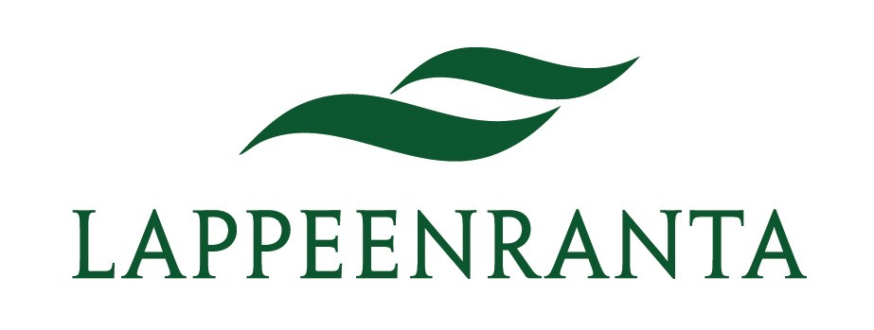 | 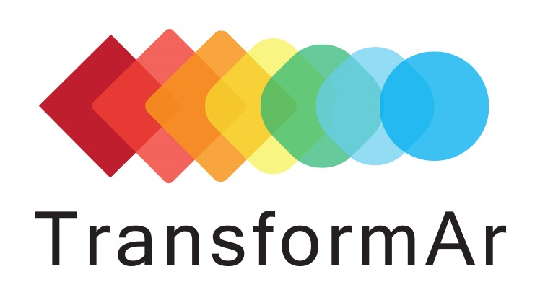 | 

Opening the event
CITY HALL SQUARE FROM 10:00 TO 17:00
Showcase solutions for climate change adaptation and stormwater management.
- Presenting stormwater management in Lappeenranta
- Showcasing nature based and technological solutions
- Representatives from City of Lappeenranta and LUT University

Launching CitySen App
CITY HALL SQUARE
Launching citizen application for raising awareness about climate change adaptation.
- Providing guidance on the application
- Demonstration of real-time monitoring of stormwater quality

NBS presentation
KOULUKATU 29-31
Guided tour starting every hour.
- Presenting the nature-based stormwater management area
- Open for school groups and everyone else interested

Citizen Science
KURKIPATSAS, CENTRAL PARK
Guidance on citizen science. Test kits available for on-site use.
- Water samples and analysis
- Guidance: how to use the test kit and upload results
- Citizen science demo

12:00

12:00

13:00

13:00

14:00

14:00

15:00

15:00

NBS presentation
KOULUKATU 29-31
Guided tour starting every hour.
- Presenting the nature-based stormwater management area
- Open for school groups and everyone else interested

Citizen Science
KURKIPATSAS, CENTRAL PARK
Guidance on citizen science. Test kits available for on-site use.
- Water samples and analysis
- Guidance: how to use the test kit and upload results
- Citizen science demo

NBS presentation
KOULUKATU 29-31
Guided tour starting every hour.
- Presenting the nature-based stormwater management area
- Open for school groups and everyone else interested

Citizen Science
KURKIPATSAS, CENTRAL PARK
Guidance on citizen science. Test kits available for on-site use.
- Water samples and analysis
- Guidance: how to use the test kit and upload results
- Citizen science demo

NBS presentation
KOULUKATU 29-31
Guided tour starting every hour.
- Presenting the nature-based stormwater management area
- Open for school groups and everyone else interested

Citizen Science
KURKIPATSAS, CENTRAL PARK
Guidance on citizen science. Test kits available for on-site use.
- Water samples and analysis
- Guidance: how to use the test kit and upload results
- Citizen science demo

NBS presentation
KOULUKATU 29-31
Guided tour starting every hour.
- Presenting the nature-based stormwater management area
- Open for school groups and everyone else interested

Citizen Science
KURKIPATSAS, CENTRAL PARK
Guidance on citizen science. Test kits available for on-site use.
- Water samples and analysis
- Guidance: how to use the test kit and upload results
- Citizen science demo

15:30

17:00

Citizen Science
CITY HALL SQUARE
Guidance on citizen science continues at the city hall square. Test kits available for on-site use.
- Water samples and analysis
- Guidance: how to use the test kit and upload results
- Citizen science demo

End of the event
CITY HALL SQUARE

